**ENR 161 Fall 2017 Chapter 6 Homework**

Name _________________________________________________ Grade ______________

Step 1:

Watch the Video Entitled, **Excel Ch06 HW F16**, this video is stored on the M drive at MCC or on youtube.com.

Step 2:

Complete the questions and problems below.

1. What is the goal of linear regression?

2. What must be done to add a Trendline to an Excel graph? What must be selected to add the Trendline equation and R2 value to an Excel graph.

3. In the Regression Analysis dialog box when should the Labels box be checked?

4. What is the purpose of a residual plot?

5. Why were different line types selected in addition to different colors for each line on the graph in the Functions worksheet?

**Grade for Questions (0-10)** ______________________

**Problem Stamp or Grade**

**Pages 260-262, Regression Function Worksheet _________**_____________

1. Complete the operations presented in Figures 6.1 to 6.4. Use named cells, show your formulas, and format your sheet as shown below.

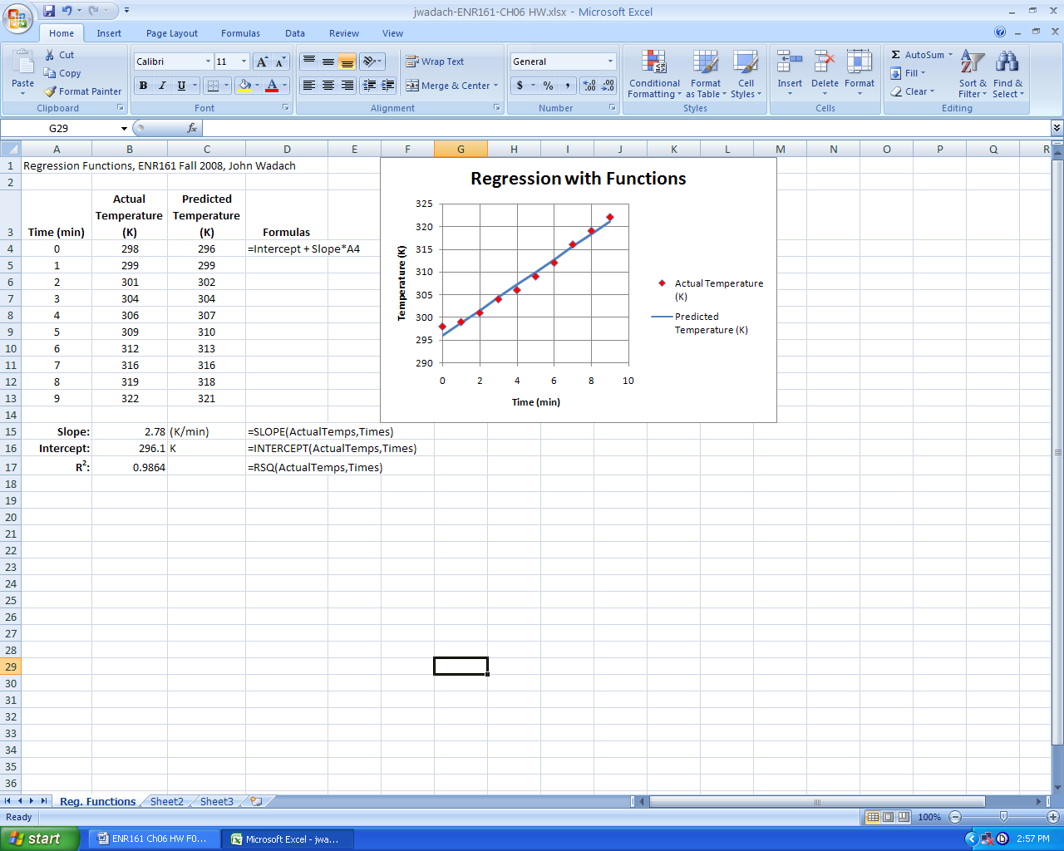

**Pages 263-270, Trendlines Worksheet _________**_____________

1. Complete the operations presented in Figures 6.5 to 6.12 in one worksheet.

2. Format your worksheet as shown below. **Be sure to add a white fill and a black border to both the trendline and legend boxes by right clicking on them and selecting Format Trendline Label.**

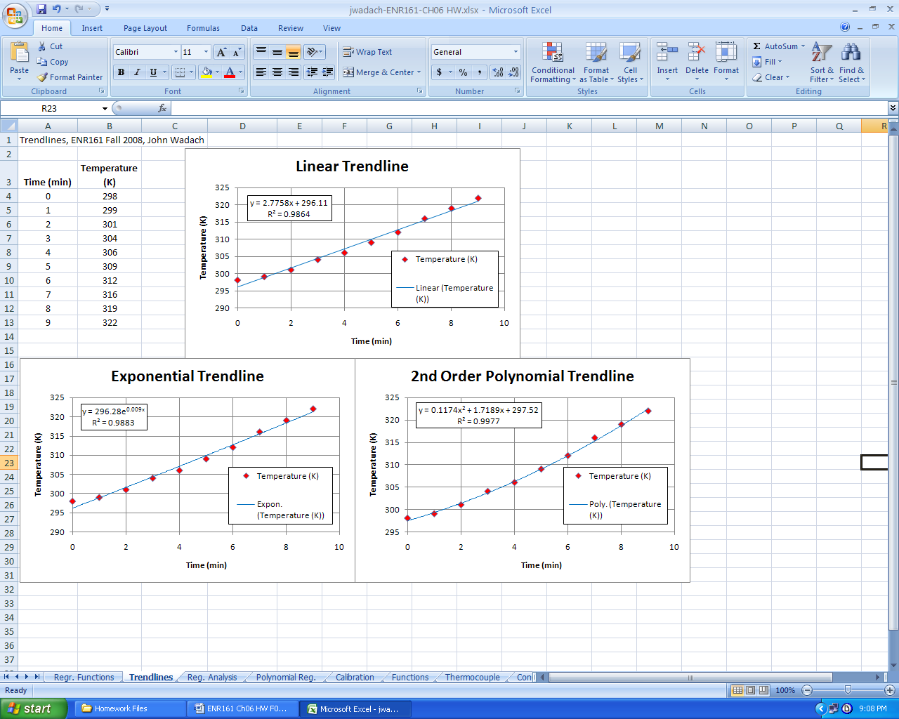

**Pages 270-278, Regression Analysis Worksheet _________**_____________

1. Complete the operations presented in Figures 6.13 to 6.26 in one worksheet. Select the Output Range as shown below. (Continued on the next page)

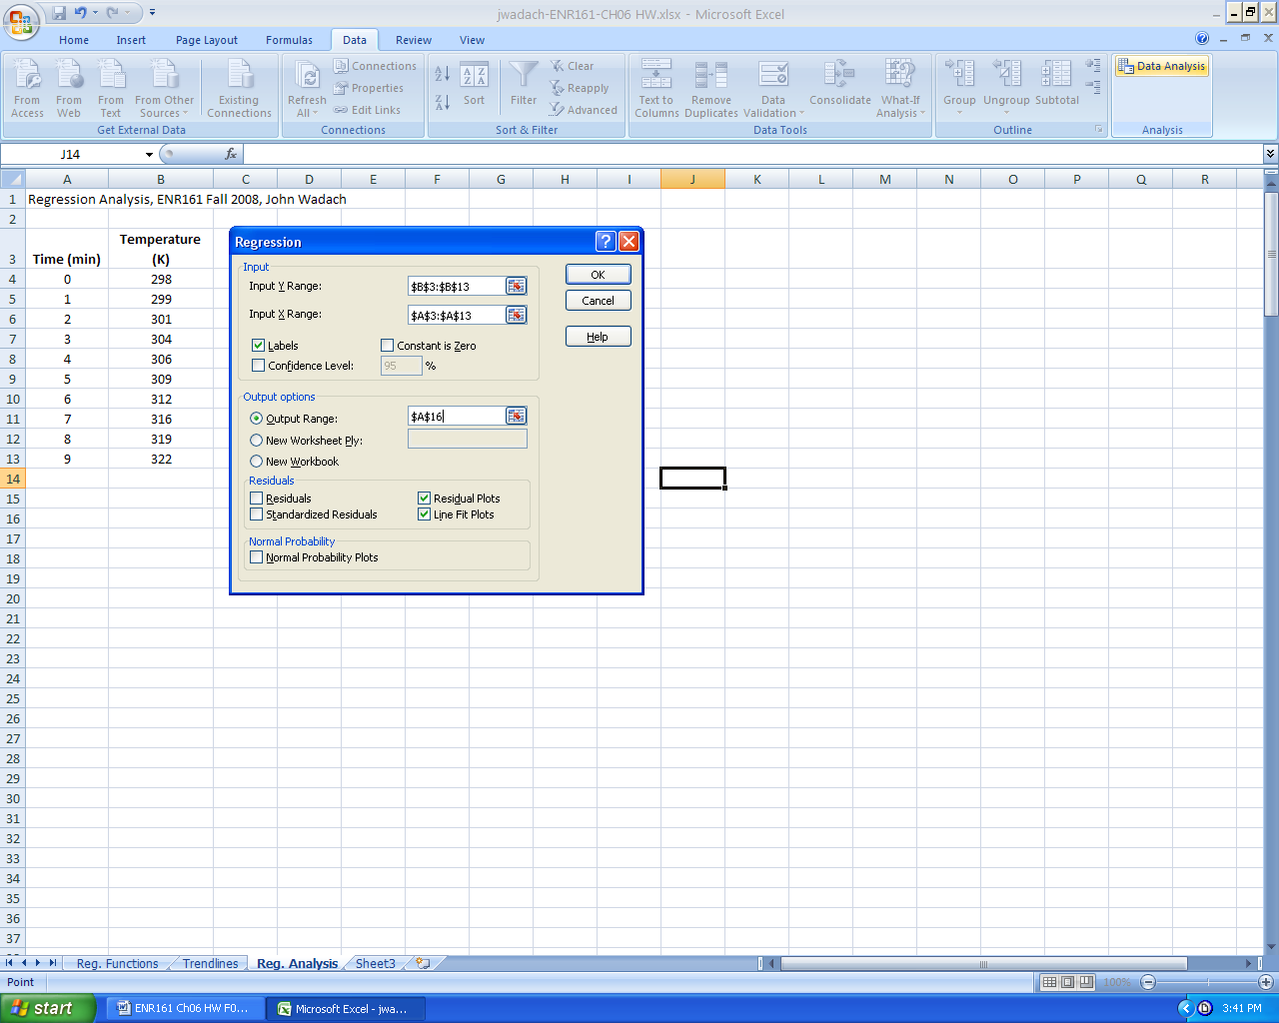

2. Format your sheet as shown below. **Be sure to type the equation for the Predicted Temperature in the title of the Line Fit Plot and highlight the coefficients as shown.** The default Line Fit Plot may not be a scatter plot. If it is not, you will have to click on the graph and then Change the Chart Type. Highlight and label the b0 and b1 values.

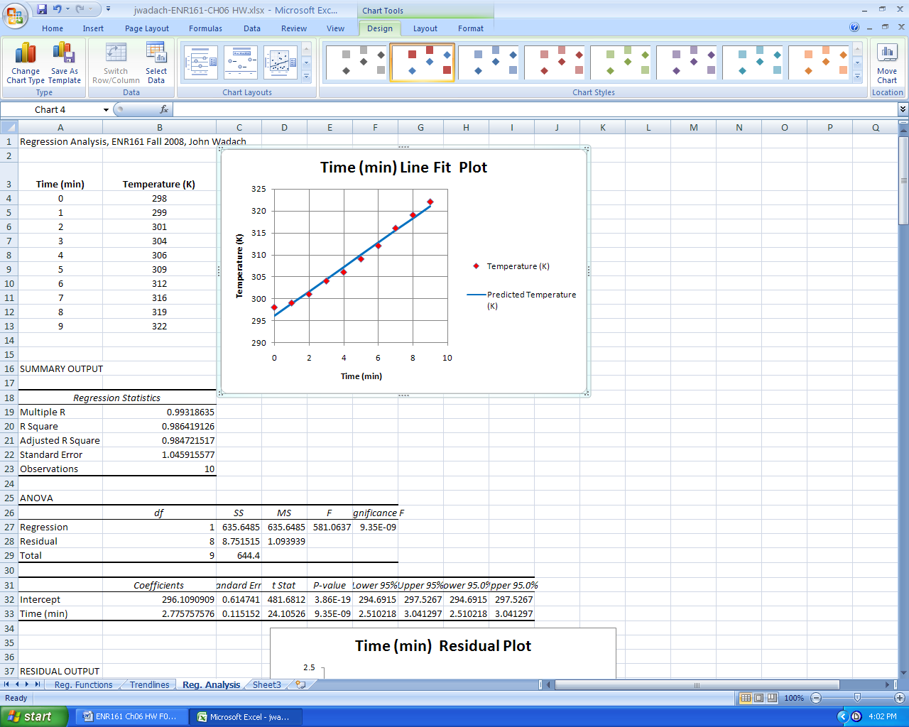

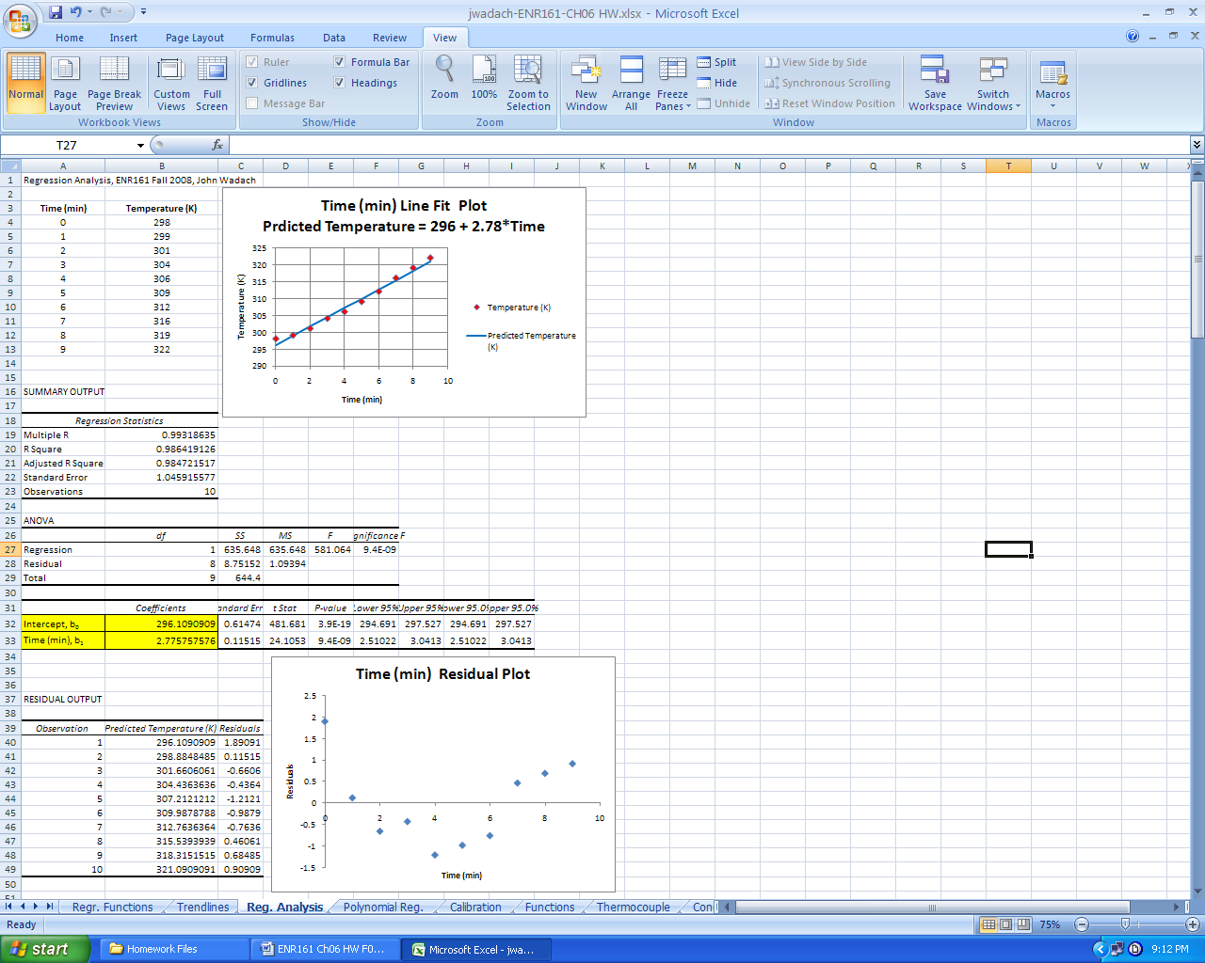

**Pages 278-281, Polynomial Regression Worksheet _________**_____________

1. Complete the operations presented in figures 6.27 to 6.31.

2. Format your worksheet as shown below. **Be sure to type the equation for the Predicted Temperature in the title of the Line Fit Plot and highlight the coefficients as shown.**

**3.** Highlight and label the b0, b1,and b2 values.

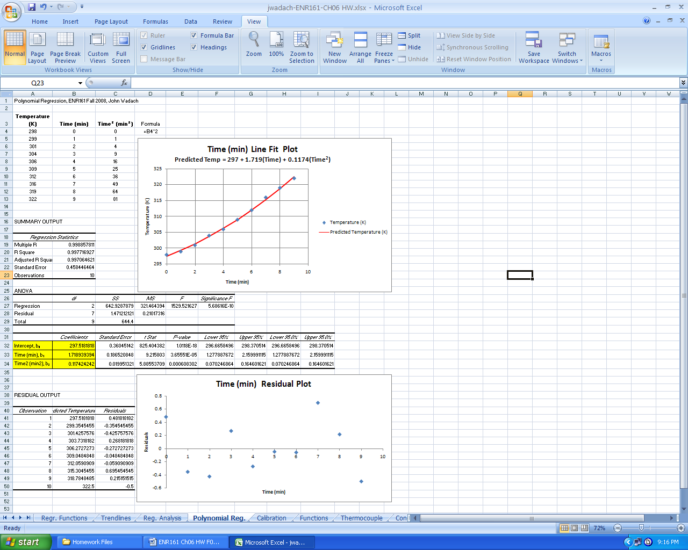

**Pages 284-286, Calibration Worksheet _________**_____________

1. Complete the operations presented in the Recalibrating a Flow Meter application.

2. Format your worksheet as shown below.

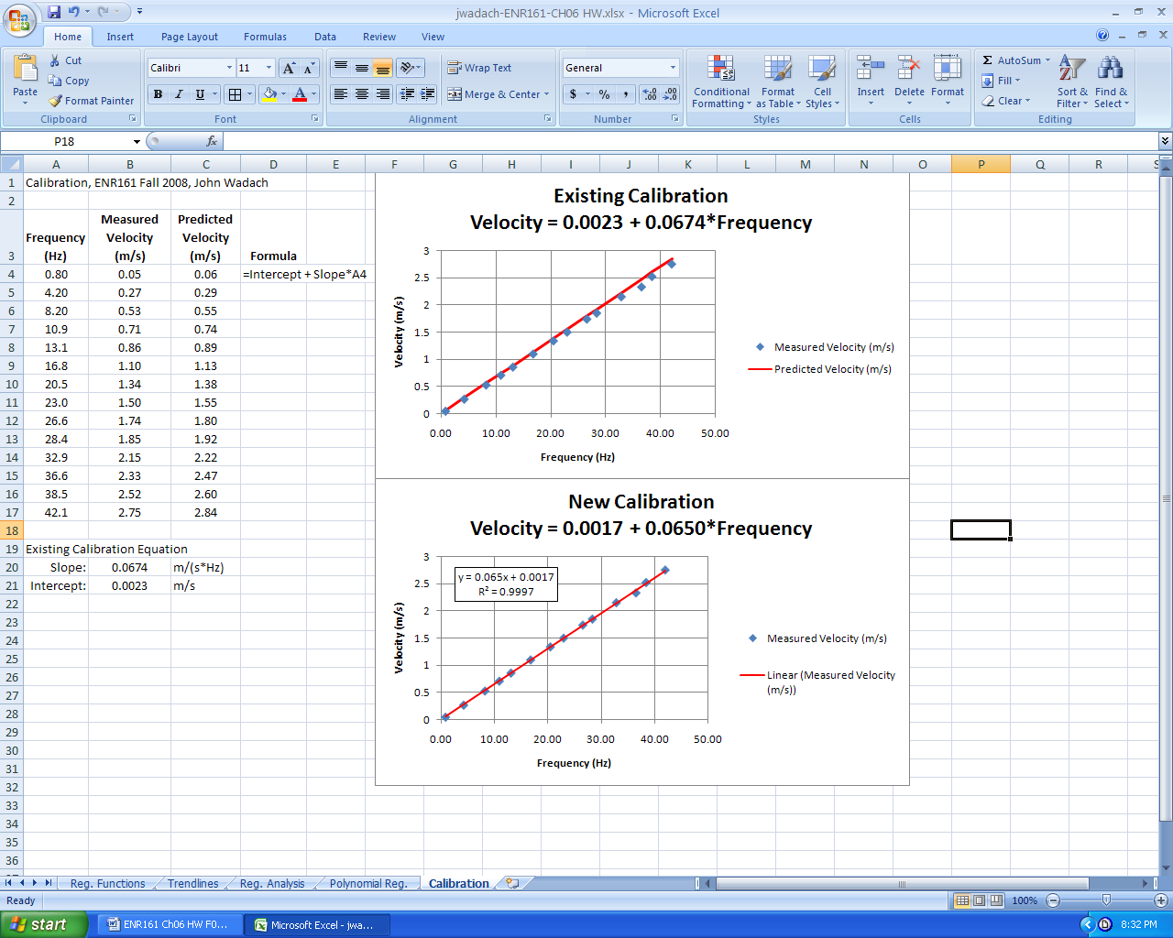

**Pages 288, Problem 6.1, Functions Worksheet _________**_____________

1. Complete problem 6.1 using the formatting shown below.

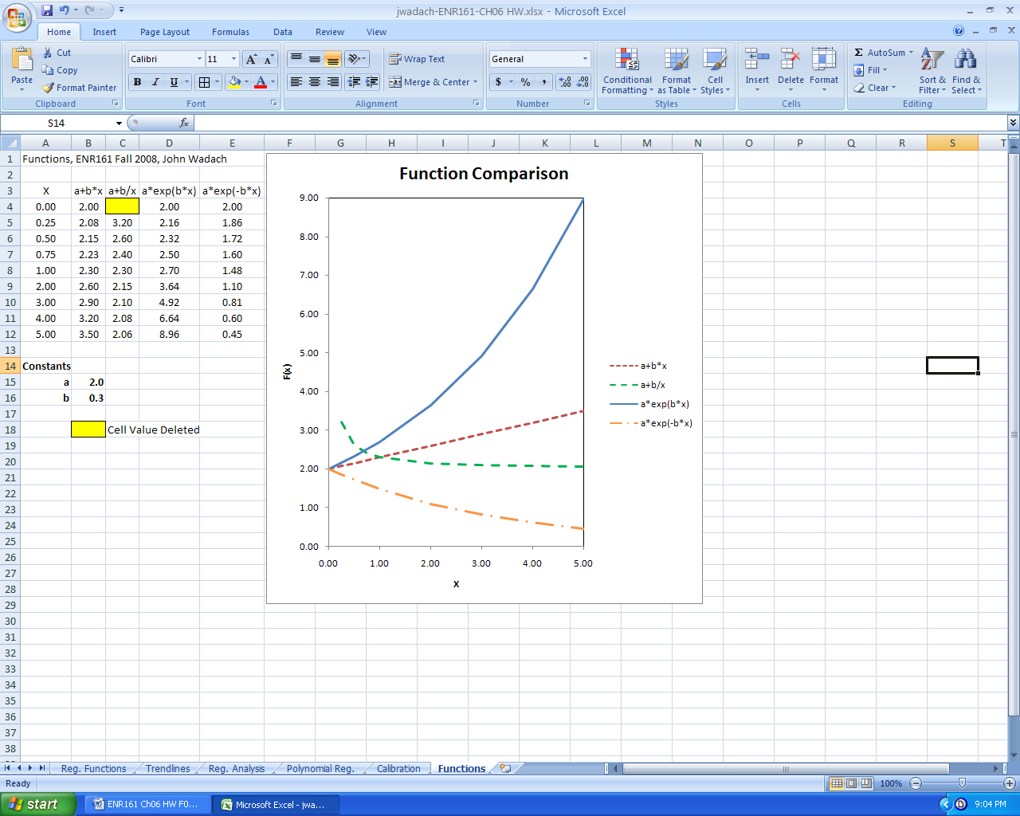

**Pages 288-289, Problem 6.3, Thermocouple Worksheet _________**_____________

1. Complete problem 6.3 using the formatting shown below.

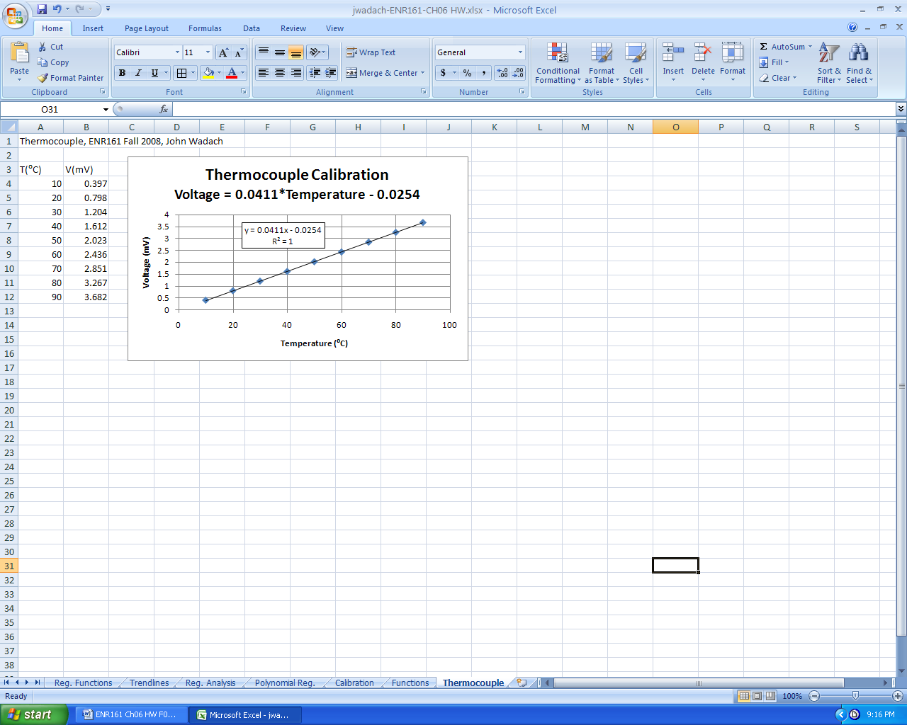

**Pages 289-290, Problem 6.4, Conduction Worksheet _________**_____________

1. Complete parts a, b,c, and answer the final question at the bottom of your sheet. In part c use named variables and state the units of each quantity.

Hint for part a: The position values of X start at 0 and increment by 5cm (0.05m).

Hint for part c: Solve for k in equation 6.9. What quantity in the trendline equation is the first derivative (dT/dx) equal to?

**Pages 292-293, Problem 6.7, Latent Heat Worksheet _________**_____________

1. Complete parts a, b,c, and d. The Ideal Gas Constant (R) = **8.314472** J · K-1 · mol-1. In part c use named variables and state the units of each quantity.

Hint for part c: Since the horizontal variable is (1/T) what quantity from the graph does (-∆Hv/R) represent?

**Pages 293-294, Problem 6.8, Orifice Worksheet _________**_____________

1. Complete parts a, b,c, and d. Format the sheet similar to the Regression Analysis worksheet. Note that the regression model is √∆P = b0 + b1(Vdot)

Notes